

D.M. Theekshana Prabodha
Network Infrastructure Proposal
Design and Implementation COT Badulla
Environment
Proposal Networking Project
Contents
1.Executive Summary 2
2.Problem Statement & Objectives 3
2.1 Problem Statement 3
2.2 Objectives 3
3.Requirements Analysis 4
3.1 Functional Requirements 4
3.2 Non-Functional Requirements 4
4.Network Design 5
4.1 Network Topology Diagram 5
4.1.1 Spatial Layout and Floor Plans 7
4.2 IP Addressing Scheme 9
4.3 VLAN Design & Access Policies 9
4.4 Routing Strategy 9
4.5 Security Design 9
4.6 Network Reliability & Redundancy 10
5.Hardware & Infrastructure Design 11
5.1 Router Selection & Justification 11
5.2 Switch Selection & Justification 11
5.3 Structured Cabling Design 13
5.4 Rack Design & Environmental Controls 15
5.5 Workstation Specifications 17
6.Bill of Materials & Cost Estimation 18
6.1 Equipment List 18
6.2 Cost Breakdown by Category 18
6.3 Final Project Investment Summary 19

7.Implementation Plan 20
7.1 Installation Steps (Timeline) 20
7.2 Configuration Methodology 20
7.3 Testing & Quality Validation 20
8.Supporting Documents 21
8.1 Detailed VLAN Management Table 21
8.2 Cable Run Calculation Summary 21
8.3 Legal & Compliance Framework 21
9.Acknowledgements & Contact 22

Executive Summary
LINK CoNet is a cutting-edge technology company specializing in network infrastructure services. Our mission is to design, implement, and maintain secure and scalable network solutions that empower businesses and educational institutions with reliable connectivity. We focus on providing innovative networking systems that cater to diverse industries, ensuring performance, security, and future scalability.
At LINK CoNet, we believe in the power of collaboration and teamwork. Our diverse team of experts brings a wealth of knowledge to every project, led by technical director D.M. Theekshana Prabodha.
This proposal outlines the development of a secure, reliable, and scalable wired network for the IT section of the institution. The primary objective is to support three specialized labs, ensuring seamless and efficient connectivity for a total of 80 workstations. By leveraging modern VLAN segmentation and star topology, the design ensures high availability, security, and ease of management.

Total Workstation Requirement for Entire Project

Lab | Description | PCs
Hardware Lab | Basic computing & hardware training | 15
NDICT Lab | Programming & database development | 35
Graphics Lab | Design & multimedia production | 30
Total Workstations |  | 80

Problem Statement & Objectives

2.1 Problem Statement
The institution currently requires a modern, segmented, and secure network infrastructure to support its IT section. With a growing number of workstations across specialized labs, the need for centralized management, traffic isolation (VLANs), and high-speed connectivity has become critical. The current environment needs to accommodate:
- Deployment Scale: Three distinct labs with 80 high-performance workstations.
- Security Requirement: Traffic isolation between labs to prevent broadcast storms, security breaches, and unauthorized inter-departmental access.
- Bandwidth Demand: High-performance design and development tasks in Graphics and NDICT labs.

2.2 Objectives
- Network Segmentation: Logical isolation of laboratory traffic via VLANs to enhance security and improve network performance.
- Secure Internet Access: Integration of an SPI firewall and strict access control policies for institutional perimeter defense.
- Centralized Management: Streamlined network administration via core/edge switch configuration and centralized performance monitoring.
- Scalability: Foundation designed to handle a 25% increase in laboratory nodes without major restructuring.

Requirements Analysis

3.1 Functional Requirements
- connectivity: High-speed internet and intranet access for all 80 workstations.
- isolation: Strict VLAN segregation for Hardware, NDICT, Graphics, and Staff networks.
- security: Granular Access Control Lists (ACLs), Port Security (MAC filtering), and DoS defense.
- monitoring: SSH/SNMP support for centralized management and remote troubleshooting.

3.2 Non-Functional Requirements
- Performance: Gigabit speeds supported via Category 6 Ethernet cabling (TIA/EIA-568-C).
- Scalability: Core switch capacity and cabling layout designed with spare ports for expansion.
- Reliability: Integrated UPS systems for power redundancy and ventilated rack housing for environmental stability.
- Compliance: Adherence to PDPA 2022, Computer Crimes Act 2007, and TRCSL regulations.

Network Design

4.1 Network Topology Diagram & Switch Placement
The network design follows a Star Topology, where each laboratory is connected to a centralized core switch in the server room. This approach ensures efficient network management, improved fault tolerance, and clear traffic isolation between different labs.

For switch placement, a distributed access layer design is used, where switches are installed inside each laboratory rather than keeping all switches in the server room.

Placing switches within labs is more practical because:

- Network cables have a maximum limit of 100 meters, and exceeding this can lead to issues such as packet loss, buffering delays, and electromagnetic interference if not properly managed
- It reduces excessive cabling between labs and the server room
- It allows for easier troubleshooting and maintenance during lab sessions

To address security and reliability concerns, a combined approach is implemented:

- Switches are placed inside locked cabinets to prevent unauthorized physical access
- Port security mechanisms are configured to block unknown or unauthorized devices
- Proper cooling and stable power supply are ensured to maintain performance

This design aligns with a hierarchical network model:

- Core Layer → Server Room
- Access Layer → Laboratory switches (secured)

Overall, this approach provides a balance between security, performance, and practical implementation in a real-world environment.
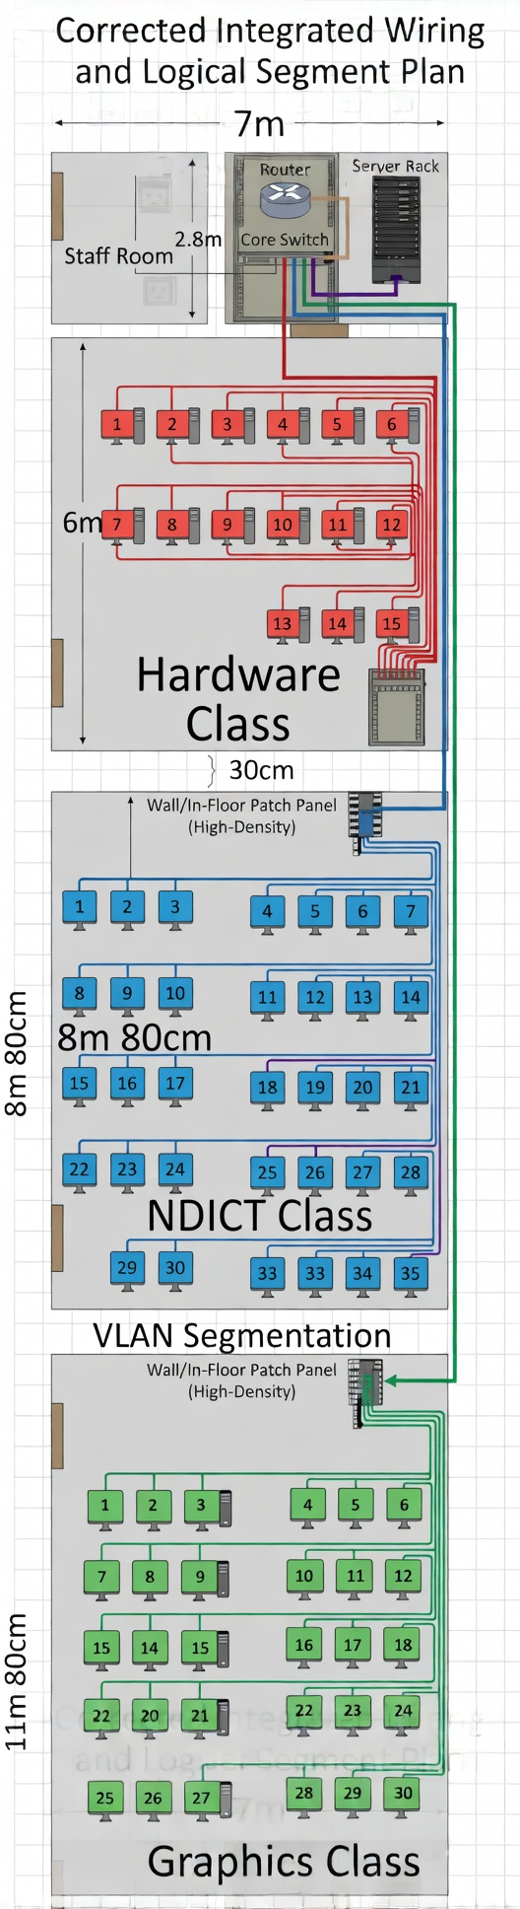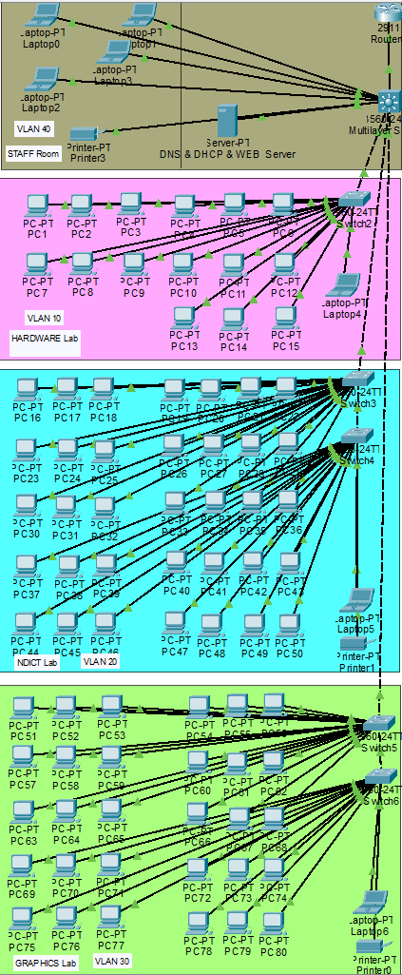
Physical Lab Layout
Logical Lab Networking Layout

4.1.1 Spatial Layout and Floor Plans
The following plans outline the physical deployment and cable routing for the IT section laboratories.
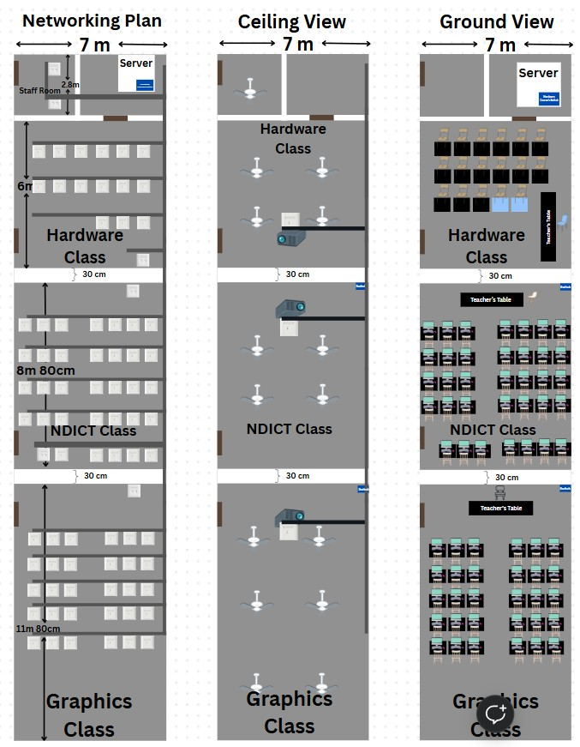

4.2 IP Addressing Scheme
The network uses a private IP addressing scheme with /24 subnets assigned to each VLAN to ensure logical grouping and ample address space.

VLAN ID | Name | Subnet | Gateway | Devices
10 | Hardware_Lab | 192.168.10.0/24 | 192.168.10.1 | 15 PCs
20 | NDICT_Lab | 192.168.20.0/24 | 192.168.20.1 | 35 PCs
30 | Graphics_Lab | 192.168.30.0/24 | 192.168.30.1 | 30 PCs
40 | Staff_Network | 192.168.40.0/24 | 192.168.40.1 | Staff

4.3 VLAN Design & Access Policies

- VLAN 10 (Hardware Lab): Basic connectivity for maintenance training. Restricted lateral access.
- VLAN 20 (NDICT Lab): Full development access for database and programming modules.
- VLAN 30 (Graphics Lab): High-priority bandwidth for design and multimedia production.
- VLAN 40 (Staff Network): Administrative VLAN with full access to core management interfaces.

4.4 Routing Strategy
Inter-VLAN routing is centrally managed by the TP-LINK TL-SG3428 Core Switch. We utilize Layer 2+ L3 Static Routing to allow efficient communication between labs while applying ACLs for security.

Device | L2+ Capabilities | VLAN Match | Comments
TL-SG3428 (Core) | Static routing | ✔ | Handles inter-VLAN routing
 | 802.1Q Tagging | ✔ | Essential for trunking and carrying multiple VLAN signals across a single link.

4.5 Security Design
- Firewall: SPI firewall integrated into the TL-ER6120 router.
- ACLs: Access Control Lists enforce strict isolation between student and staff VLANs.
- Port Security: IP-MAC-Port binding and port security enabled on all edge switches to prevent unauthorized device connection.
- Storm Control: Mitigation of abnormal broadcast traffic to ensure network stability.

4.6 Network Reliability & Redundancy
This network is designed to ensure high reliability and continuous availability of services. A hierarchical structure using core and edge switches helps minimize single points of failure and improves fault isolation.

Redundant backbone links can be implemented between core and edge switches to maintain connectivity in case of cable or port failure. Quality cabling standards (Cat6) and proper cable management are used to reduce signal loss and physical damage risks.

Additionally, switches support features such as Spanning Tree Protocol (STP) to prevent network loops and ensure stable data transmission. These measures help maintain consistent network performance and reduce downtime in the event of failures.

Hardware & Infrastructure Design

5.1 Router Selection & Justification
TP-LINK TL-ER6120 Gigabit Multi-WAN VPN Router - Capability: Multi-WAN for redundant ISPs and robust firewall/VPN features. - Firewall Policy: Integrated stateful packet inspection.
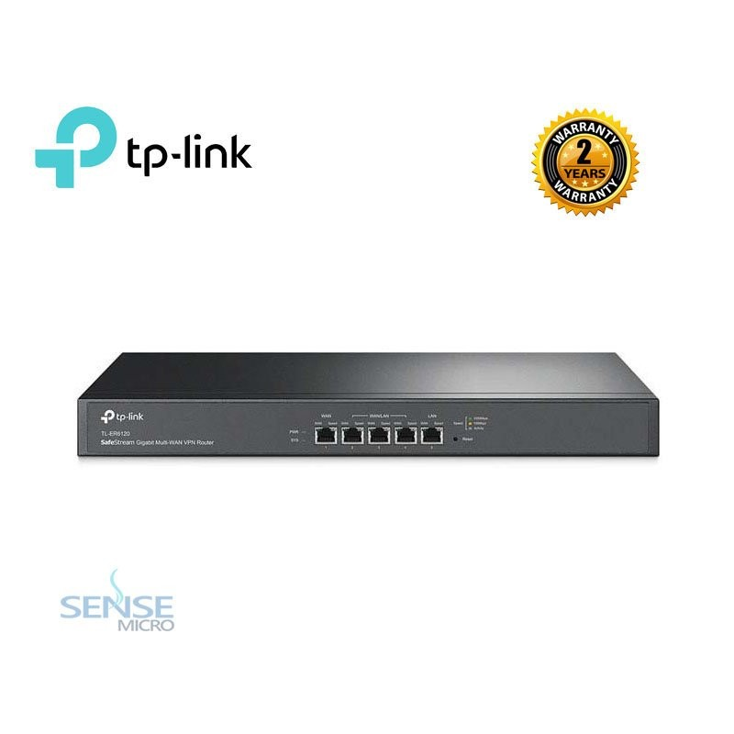
Figure 4: Selected Gigabit Multi-WAN Core Router

5.2 Switch Selection & Justification
Core Switch: TP-LINK TL-SG3428 JetStream - Justification: 24-Port L2+ managed capabilities with 4 SFP slots for fiber uplinks.
Edge Switch: TP-LINK TL-SG2218 - Justification: 16-Port Managed Switch ideal for laboratory distribution.
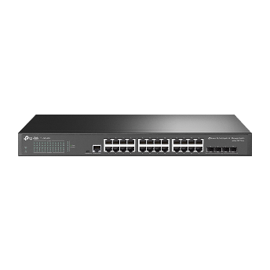
Figure 5: Managed Switching Infrastructure

5.3 Structured Cabling Design
We strictly adhere to TIA/EIA-568-C / ISO/IEC 11801 standards for Category 6 UTP cabling. All runs are labeled and housed in PVC conduits.

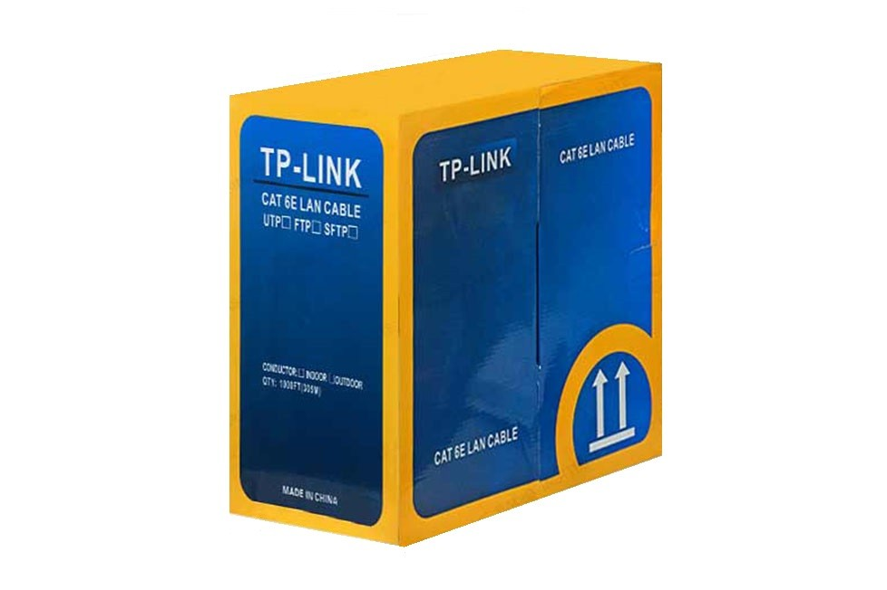

Cabling Components:

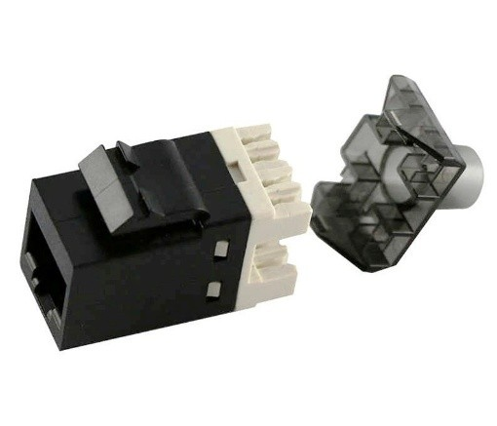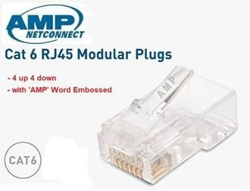
Figure 6: High-Performance Cat6 Keystone Jacks and RJ45 Connectors

Infrastructure Termination:

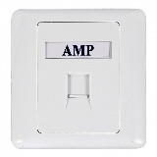
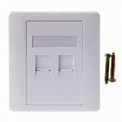
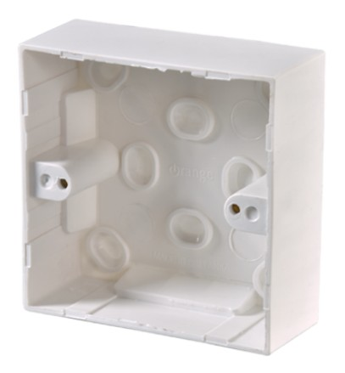

Figure 7: Wall Faceplate and Sunkbox Infrastructure

5.4 Rack Design & Environmental Controls
The core will be housed in 16U Wall-Mount Ventilated Racks with integrated power and cooling management.
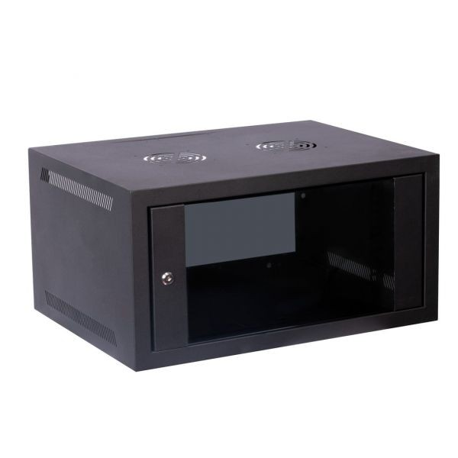
Figure 8: 16U Ventilated Network Rack
Power & Cable Management:
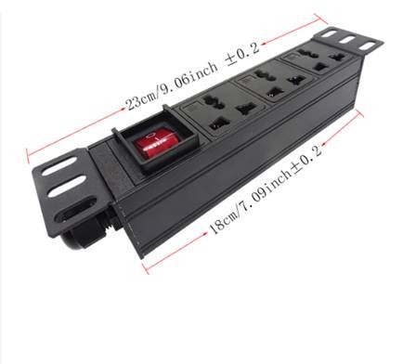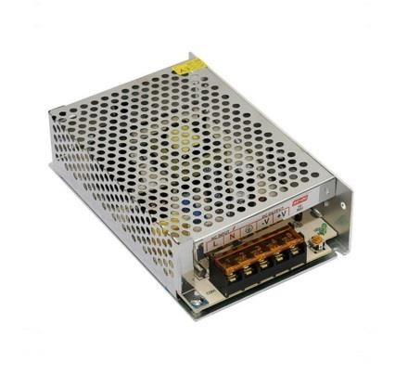
Figure 9: Rack-Mounted PDU and Network Component Power Supply
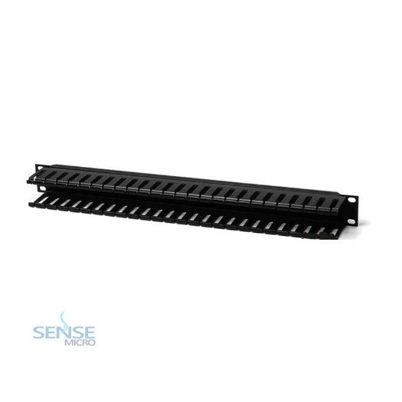
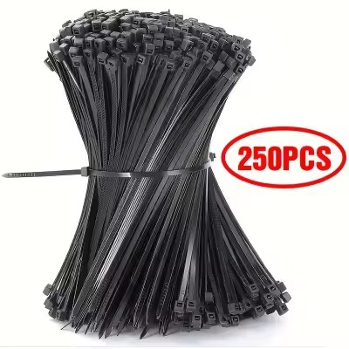
Figure 10: Horizontal Cable Management and Fastening Systems


Figure 11: 650VA Line-Interactive UPS for core reliability

5.5 Workstation Specifications
We have tailored the PC configurations to the specific pedagogical needs of each laboratory.

Specification | Hardware Lab | NDICT Lab | Graphics Lab
CPU | Ryzen 3 3200G | Ryzen 5 5600G | Ryzen 5 5600G
RAM | 8GB DDR4 | 8GB DDR4 | 8GB DDR4
Storage | 128GB SSD + 1TB HDD | 128GB SSD + 1TB HDD | 128GB SSD + 1TB HDD
Monitor | 19” LED | 22” LED | 22” IPS LED
UPS | DCP 650VA | DCP 650VA | DCP 650VA
Motherboard | A320 chipset | A520 chipset | B450 or A520
Warranty | Manufacturer backed | Manufacturer backed | Manufacturer backed

Bill of Materials & Cost Estimation

6.1 Equipment List
Item Category | Model / Specifications | Qty | Unit Cost (LKR) | Subtotal (LKR)
Core Switching | TP-LINK TL-SG3428 (L2+ Managed) | 3 | 72,000 | 216,000
Edge Switching | TP-LINK TL-SG2218 (Smart Managed) | 3 | 52,250 | 156,750
Enclosures | 16U Ventilated Wall-Mount Rack + PDU | 3 | 41,867 | 125,600
Patching Hardware | 24-Port Cat6 High-Density Panel | 6 | 31,500 | 189,000
Bulk Media | Cat6 305m UTP Pull Box (Bulk) | 6 | 19,500 | 117,000
Termination | Cat6 Keystone Jacks (110-Style) | 110 | 380 | 41,800
Outlets | Modular Wall Plates (Single/Double) | 98 | 275 | 26,950
User Access | RJ45 Single Gang Faceplates | 90 | 270 | 24,300
Organization | Horizontal & Vertical Cable Managers | 8 | 1,750 | 14,000
Professional Services | Site Work, Termination, & Configuration | 1 | 115,000 | 115,000
GRAND TOTAL | Full Lab Deployment (LKR) |  |  | 1,026,400

6.2 Cost Breakdown by Category
Category | Investment Details | Total Cost (LKR)
Network Core | Routers, Switches (L2+), Racks, and structured Cabling (Cat6/6a) | 911,400
Workstations | 80 Multi-level Editing/Design PCs for specialized labs | 9,807,000
Labor & Survey | Site survey, cable termination, and network configuration | 115,000
Total Project Cost | Comprehensive Infrastructure & Hardware Deployment | 10,833,400

6.3 Final Project Investment Summary
Grand Total: LKR 10,833,400

Implementation Plan

7.1 Installation Steps (Timeline)
- Week 1-2 (Planning): Site surveys mapped to floor plans, final equipment procurement checklist.
- Week 2-4 (Infrastructure): Horizontal cable pulls, keystone termination, floor/conduit installation.
- Week 5 (Equipment Setup): Core rack mounting, power initialization (UPS/PDU), cooling fans setup.
- Week 6-7 (Configuration): Port security assignment, VLAN tagging on trunks, router ISP bonding (Multi-WAN).
- Week 8-10 (Testing & Validation): Lab-by-lab connectivity tests, firewall simulation, and project handover.

7.2 Configuration Methodology
- Logical Design: VLAN ID assignment (10, 20, 30, 40) logic applied to core routing tables.
- Traffic Control: Access Control Lists (ACLs) applied to inter-VLAN interfaces.
- Security: Implementation of Port Security (MAC Binding) on lab edge ports.
- Resilience: Multi-WAN failover logic configured on the TL-ER6120 Core Router.

7.3 Testing & Quality Validation
- Connectivity: Verification of 100% throughput reaching all 80 PCs.
- Isolation: Attempted cross-VLAN pings to verify ACL efficacy.
- Load Test: Simultaneous high-bandwidth simulation in the Graphics Lab to verify QoS.

Supporting Documents

8.1 Detailed VLAN Management Table
VLAN ID | Name | Subnet | Gateway | Purpose
10 | Hardware_Lab | 192.168.10.0/24 | 192.168.10.1 | Training Lab & Hardware Testing
20 | NDICT_Lab | 192.168.20.0/24 | 192.168.20.1 | Software Development & Networking
30 | Graphics_Lab | 192.168.30.0/24 | 192.168.30.1 | Multimedia & High-End Design
40 | Staff_Network | 192.168.40.0/24 | 192.168.40.1 | Administration & Faculty Access

8.2 Cable Run Calculation Summary
Requirement | Length (m) | Type | Notes
Horizontal Wall Drops | 980 | Cat6 Bulk | Permanent links from patch panels to lab wall outlets.
Workstation Patch Leads | 200 | Cat6 Patch | Connecting 80 PCs to the wall outlets (approx. 2.5m per lead).
Switch/Patch Leads | 238 | Cat6 Patch | Short runs for rack cable management between switches and panels.
Total Order Recommendation | 1,525m | Cat6 | Standard 305m (1000ft) Pull Boxes

8.3 Legal & Compliance Framework
- PDPA 2022: Ensuring data sovereignty within student networks via logical isolation.
- Computer Crimes Act 2007: Active logging and unauthorized intrusion prevention.
- TRCSL Compliance: All equipment is Sri Lanka Telecommunications Regulatory Commission type approved.
- Standards: Adherence to IEEE 802.1Q (VLAN Tagging) and TIA/EIA-568.

Acknowledgements & Contact
We extend our heartfelt gratitude to the instructors, mentors, and the institution for their continued support throughout the development of this network infrastructure project.

Project Leader: D.M. Theekshana Prabodha Technical Director, LINK CoNet

Company Contact: - Email: info@theeknet.com - Web: www.theeknet.com - Location: Network Infrastructure Division

“Reliable infrastructure is the backbone of a connected future.” — Team LINK CoNet

